

**Course title: Neural Network and Fuzzy Systems Lab**

**Course Code: CSE-451**

**Project Report For:**

**Finding Path using Reinforcement (Q-learning)**

**Supervisor:**

## Noushad Sojib



**Submitted by:**

## Md. Ruhul Alom

**ID no: 170103020046**

**11th Semester**

## Md. Abu Shahan

**ID no: 170103020017**

**11th Semester**

**Date:17/10/2020**



**Introduction:**

Reinforcement learning in formal terms is a method of machine learning where in the software agent learns to perform certain actions in an environment which lead it to maximum reward. It does so by exploration and exploitation of knowledge it learns by repeated trials of maximizing the reward.

The main goal of this project to find path from random starting point to specific end point

**Simple Data**

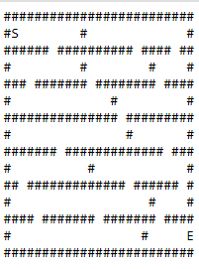

Where, S = starting point

E = Ending point

# = obstacle or wall

Space ( ) denote general path where agent can move for finding the best path.

**Brief description of the steps:**

1. First of all, we are import text file (mazetrix.txt) which hold some symbol same as simple data which we have been demonstrated earlier.
2. Then we designed graphical interface based on text file.in graphical interface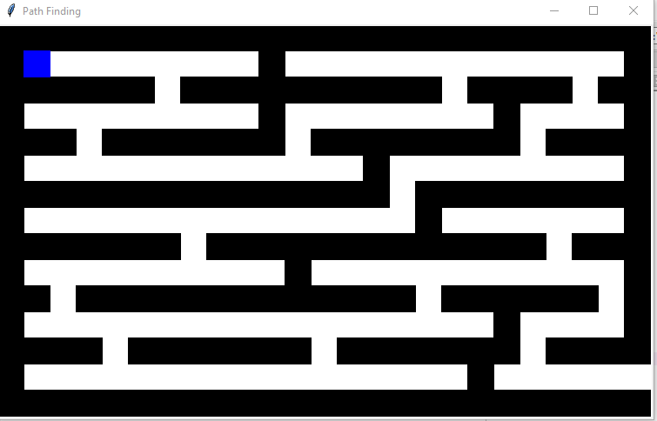

Where starting point design by blue color, path design by white color and wall design by black color.

1. Implement Q-learning on graphical interface.
2. In the beginning of q-learning implementation first we set the possible of action in this environment then we set the reward for every state. Where possible action are [left, right, up, down] and initial reward for every possible movement we set -1. For wall or obstacle we set -100. For goal state we set +100. We make a Q table with 3 dimension for storing the update value, Using Q-learning update rule we find the update value and we assign the update value into Q-table. This sequence will run a fixed range.in this algorithm we use 10000.

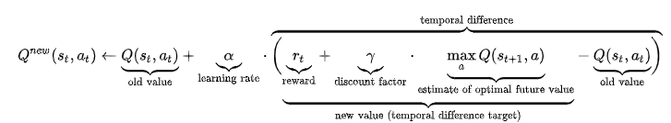

1. We choose 2 random point (S, E) in text file. Where ‘S’=starting point and ‘E’=ending point.
2. Agent use Q-learning and show best path from string to ending.

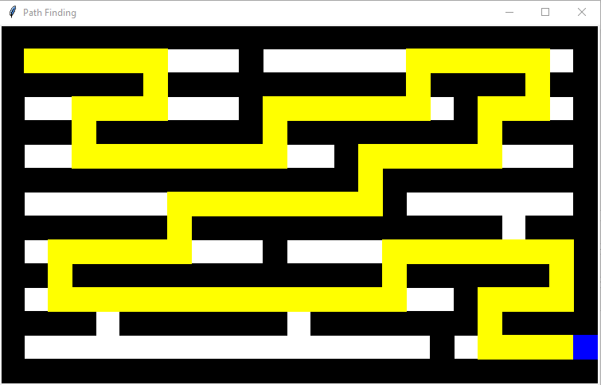

Sample Output

**Challenges:**

* **To set the reward in the environment.**
* **Showing Agent movement.**